Names: Ryan Keyser, Abdur Naveed, Joshua Budd, Nathaniel Sullivan

Requirements

1. Final User: Adult stroke patients
2. Problem Statement: Patients who have suffered from a stroke can be lacking in fine motor skill abilities. In order to help stroke patients recover their fine motor skills such as pencil skills, hand eye coordination and self care, we will create a game which will not only help progress their skills but also keep them engaged.
3. Pain points:

* Screen brightness for damaging eyes over time
* Breaks in between sessions
* Adults are learning many other skills all by doing different things
* Adults don’t want their time to be wasted
* Have a busy schedule and not a lot of spare time
* May be discouraged because they have lost a skill they once had
* Rebuilding motor skills takes a lot of time
* Lots of tasks adults are required to do require fine motor skills
* Goals need to be set in place so he/she can feel rewarded by making progress
* Adults do not have the highest attention span so activities need to be really interesting from the start

Questions:

* What are the main motor skills you are struggling with?
* How long have you been having these problems?
* What games and activities are you currently interested in?
* What keeps you engaged?
* How much time do you have each day?

| Activities | Challenges |
| --- | --- |
| Opening up a water bottle | * One hand has tight grip over water bottle * Other hand needs to reach precisely for the small cap * Hand on cap needs to twist the cap until it opens |
| Putting legos together    Source: Dreamstime.com    Source: Oracles Blogs | * Grab a lego * Move your hand so it is on top of another lego * Place the first lego on top of the other lego so the holes match up |
| Writing on a paper | * Hold pencil * Apply limited pressure to the pencil * Drag pencil head of paper in specific shapes of letters |
| Unlocking and opening a door    Source: Amazon    Source: United Locksmith    Source: Dreamstime.com | * Get key out of pocket and hold it from the back * Put the key near the key hole and make sure it is perpendicular to the ground so it fits in the key hole * Put the key in the key hole and twist * Once lock is unlocked, pull the key out by twisting it how it was before * Use your other hand to twist the door knob and push to open the door |
| Brushing teeth    Source: Quora    Source: Dreamstime    Source: Westermeier Martin Dental Care | * Take toothpaste container and open it * Squeeze a nominal amount of toothpaste from tube and applying it to the toothbrush head * Close toothpaste and grab toothbrush * Move toothbrush in a circular pattern across the fronts, tops, and backs of teeth |
| Washing hands    Source: HGTV    Source: InsideHook    Source: USA Today    Source: Reader’s Digest | * Turn the water on by turning the knob * Grab the bar of soap and put it under the running water to wet the soap a bit * Pull the soap out and rub it on your hands * Put the soap back and scrub your hands for 20 seconds * Wash the soap off but putting your hands under the running water * Scrub your hands under the running water until all the soap is off * Turn the water off but turning the knob |
| Flossing teeth    Source: Alamy    Source: News Medical | * Pull a specific amount of floss from the container * Cut floss by pulling floss against metal cutter * Delicately take floss and push between teeth and repeat for all teeth |
| Putting cable into controller | * Grab end of charging cable * Orient cable to align with charging port * Apply force to the rigid end of cable while it is aligned with the hole until it clicks |
| Mopping the floor  Source: wikiHow    Source: ServiceMaster of Wake County | * Hold mop with two hands * Submerge mop into water in bucket * Use wet mop on floor to mop it * Wring out mop over the bucket |
| Cracking an egg    Source: The Spruce Eats    Source: Eat this, not that | * Grab an egg and hit it with slight force against the side of your bowl or countertop * Insert your thumbs in the crack you just created * Pulled your thumbs apart |

Exercises:

* Lining Drawing game
* Shooting practice game
* Simon says typing game

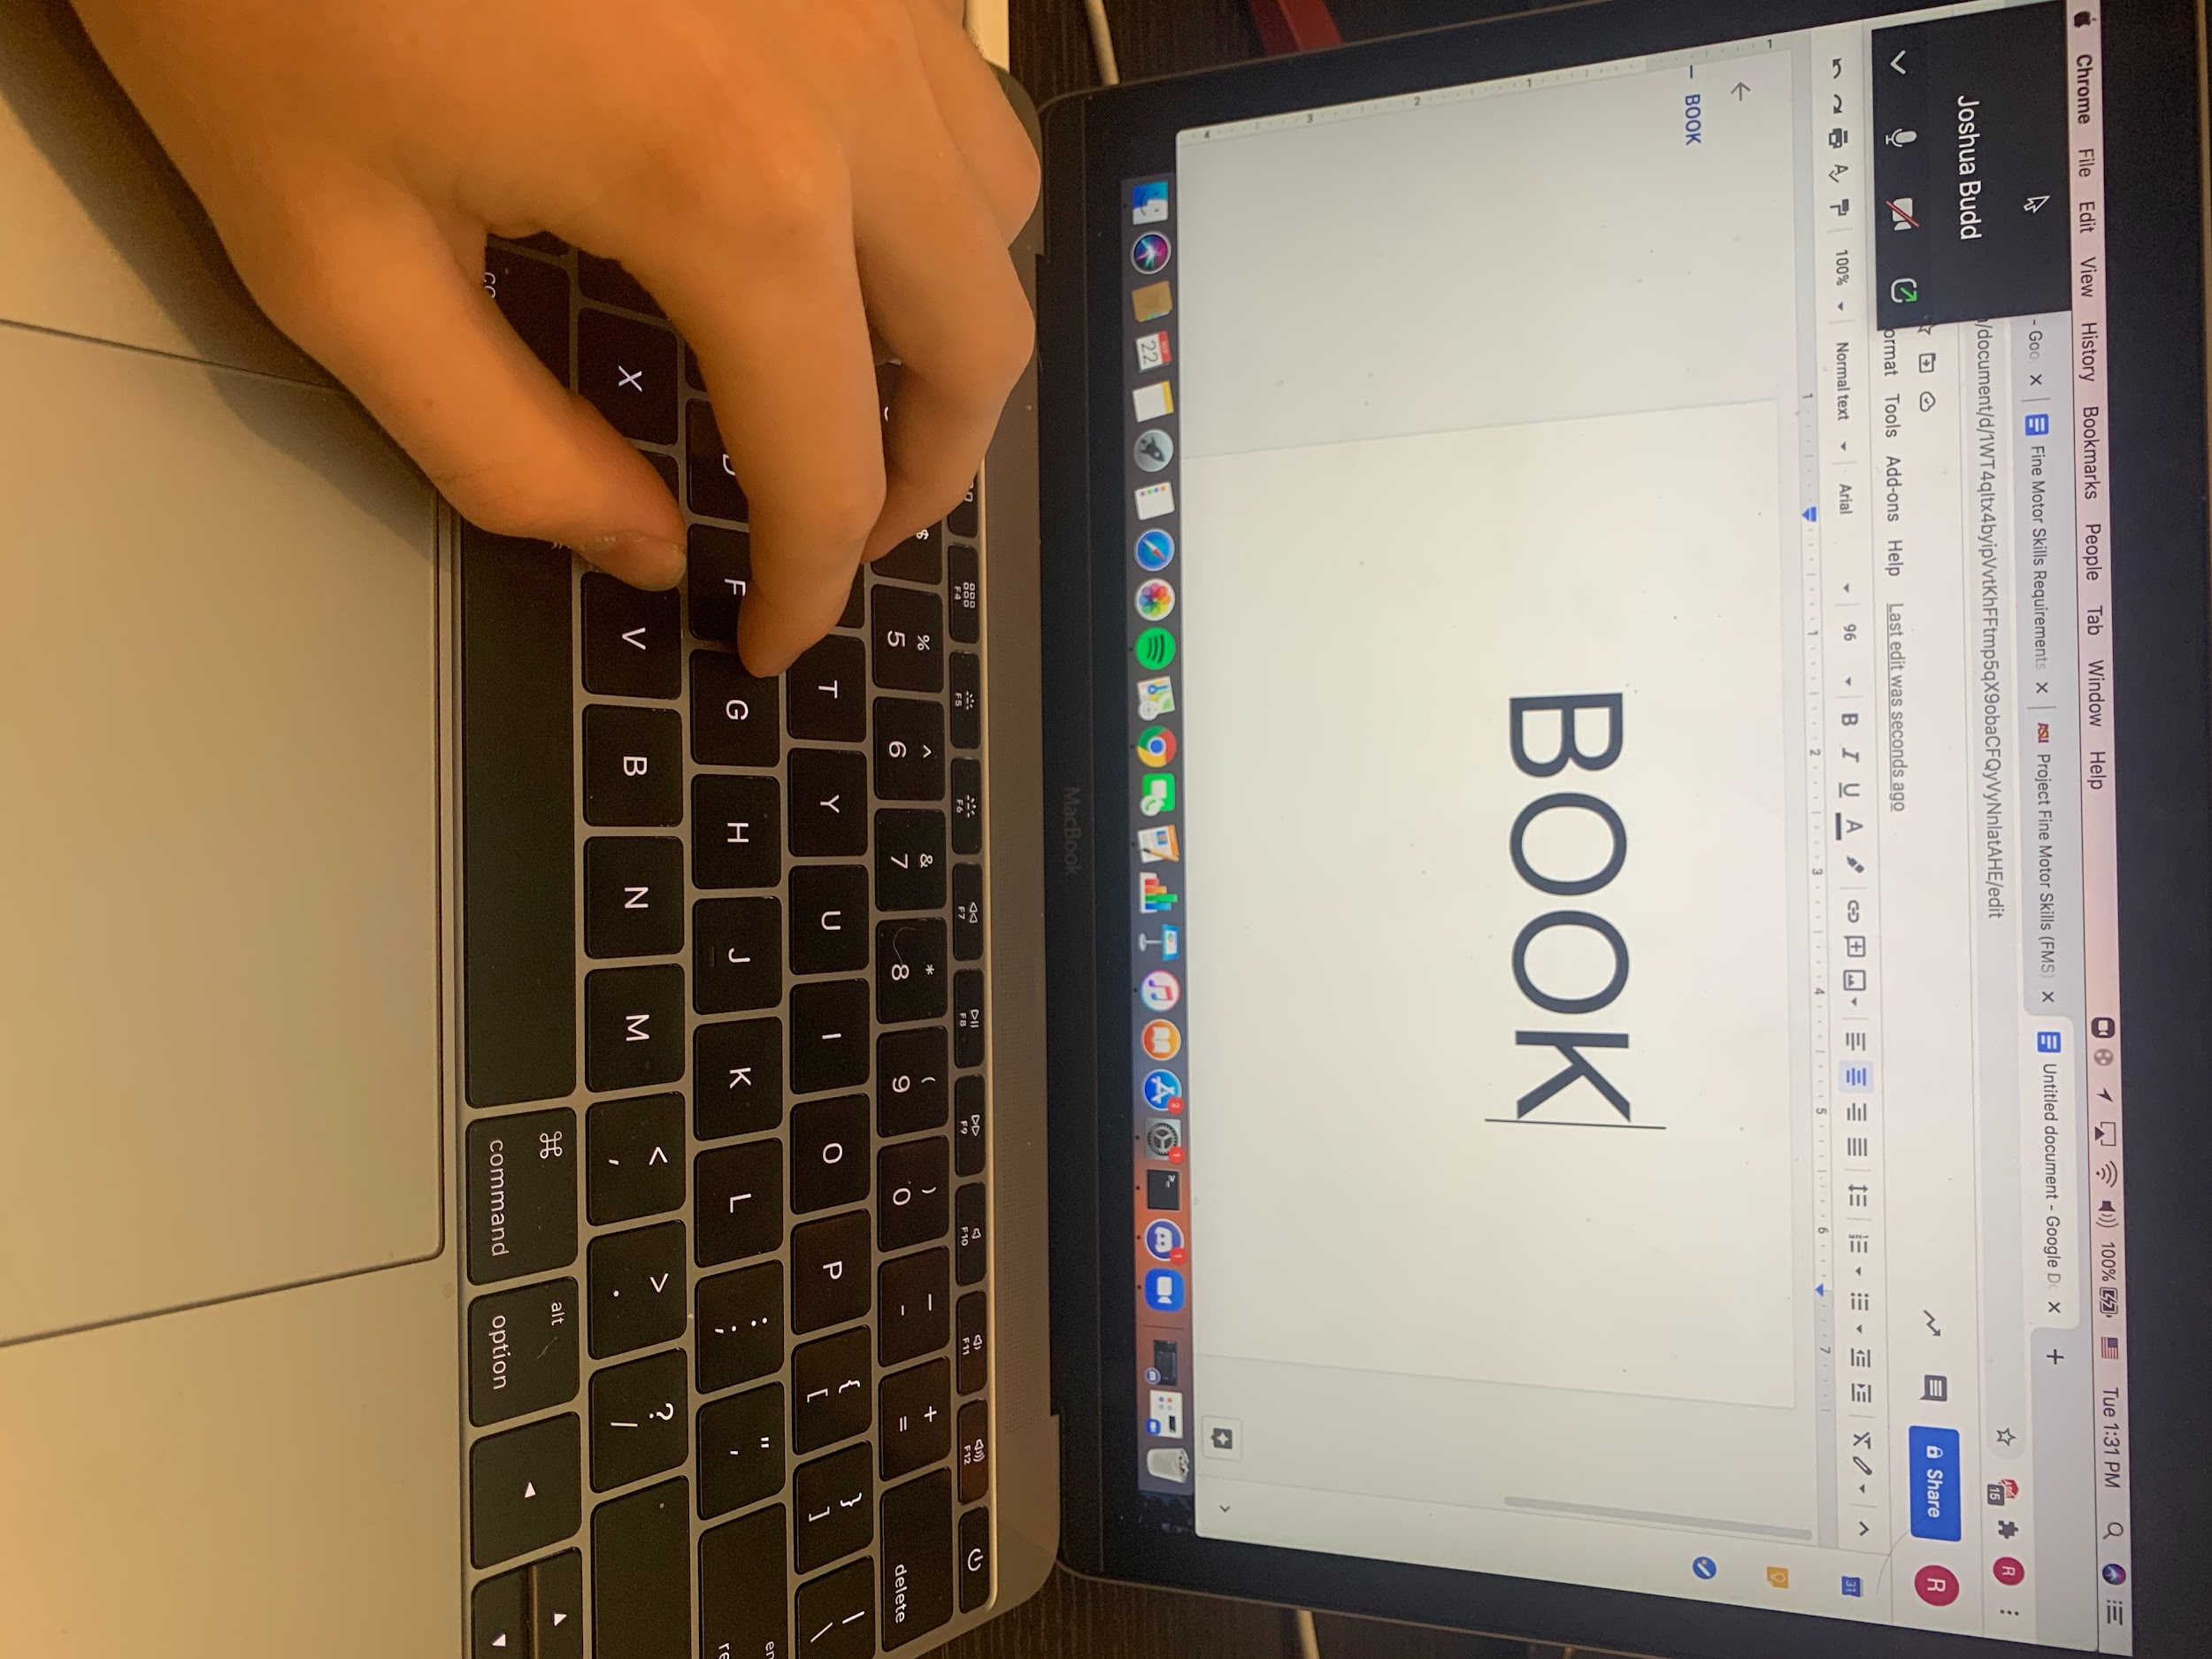



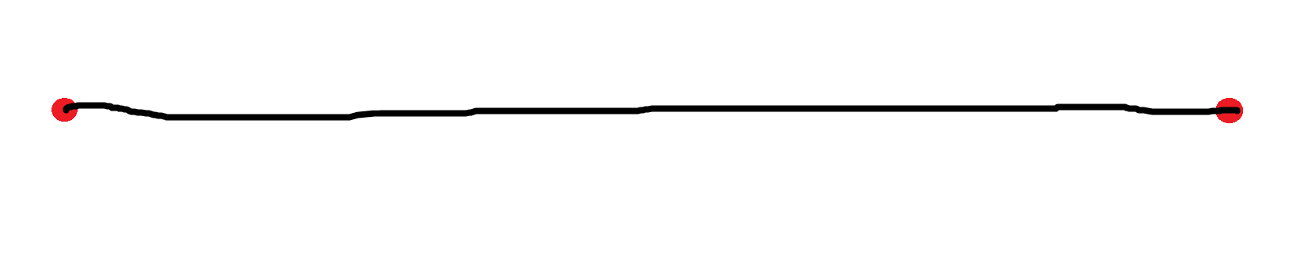

Example screenshot taken from: [Aim Trainer](https://aimtrainer.io/)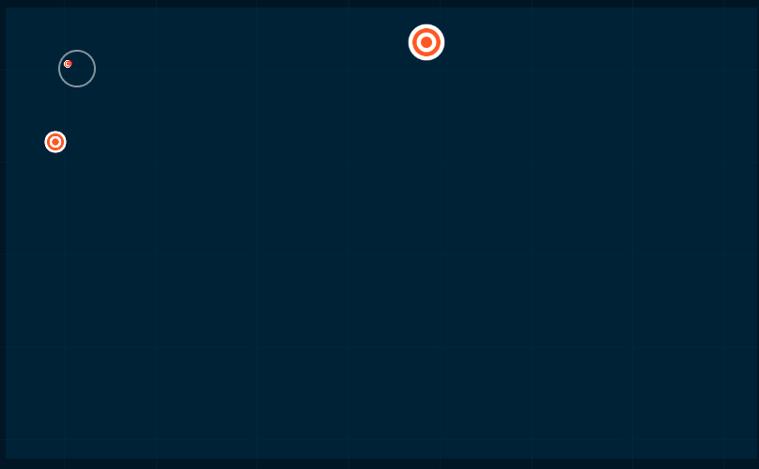

4) Requirements:

Functional:

* The program should have different exercises.
* Program should give back feedback to the user.
* The program should help users increase their abilities in the above activities.

Performance:

* There should be three different exercises.
* Feedback should either be visual, auditory, or both.
* Users’ performances in the above activities should increase by 10% in speed and 10% in consistency.

Constraints:

* The program must be a web based application using p5.js.
* The program must be completed before the due date.